

**Asia Pacific College**

**#3 Humabon Place, Magallanes, Makati City**

**Public School Ranking System**

**Project Documentation**

**Submitted to the Faculty of**

**School of Computing and Information Technologies**

**In Partial Fulfillment of the Requirements**

**for the subject Project Management**

**Submitted by:**

**AYUNGON, Rhea-Eve M.**

**BURTON, Kathrine Danielle C.**

**JULIAN, Kyla Joyce M.**

**LLANTOS, Joneil Thom O.**

**Submitted to:**

**Manuel L. Calimlim Jr.**

**Subject Professor**

**APRIL 24, 2018**

**TABLE OF CONTENTS**

**I.** **INTRODUCTION** 4

**A.** **Project Overview** 4

**B.** **Purpose** 5

**C.** **Scope** 5

**D.** **Objectives** 5

**E.** **Company Profile** 6

**F.** **Data Gathering** 7

**G.** **Goals and Objectives of the System** 7

**H.** **Assumptions, Constraints, Risk** 8

**I.** **Project Deliverables** 9

**J.** **Definitions and Acronyms** 9

**II.** **STAKEHOLDERS MANAGEMENT STRATEGY** 10

**A.** **Purpose** 10

**B.** **Stakeholder Analysis** 10

**III.** **PROJECT ORGANIZATION** 12

**A.** **External Structure** 12

**B.** **Internal Structure** 12

**C.** **Roles and Responsibilities** 13

**IV.** **MANAGERIAL PROCESS PLAN** 14

**A.** **Start Up Plan** 14

**4.1.1 Estimates** 14

**4.1.2 Staffing** 15

**4.1.3 Procurement Plan** 16

**4.1.4 Project Staffing Training** 20

**B.** **Work Plan** 21

**4.2.1 Work Breakdown Structure (WBS)** 21

**4.2.2 Resource Allocation** 22

**C.** **Project Tracking Plan** 22

**4.3.1 Requirements Management** 22

**4.3.2 Schedule Control** 23

**4.3.3 Budget Plan** 24

**4.3.5 Quality Control / Quality Assurance Plan** 25

**4.3.5 Contingency Plan** 27

**4.3.6 Communication Plan** 27

**4.3.7 Project Metrics** 28

**D.** **Risk Management Plan** 30

**E.** **Project Closeout Plan** 31

**V.** **TECHNICAL PROCESS PLAN** 31

**A.** **Process Model** 31

**B.** **Methods, Tools and Techniques** 32

**C.** **Product Acceptance** 32

**VI.** **SUPPORTING PROCESS PLAN** 33

**A.** **Configuration Management** 33

**B.** **Documentation** 33

**C.** **Process Improvement** 34

**VII.** **REFERENCES** 35

# **INTRODUCTION**

## **Project Overview**

Elementary education is the first part of the educational system, and it includes the first six years of compulsory education from grade 1 to 6, with an optional 7th grade offered by some schools. Major subjects include Mathematics, Science, English, Filipino and Araling Panlipunan. On the other hand, optional subjects include Music, Arts, Physical Education, and Health.

As of School Year 2017-2018, there are 22.9 Million students that are enrolled in public schools in the Philippines and the country’s Department of Education has been doing their job in providing quality education both for private and public sectors. However, there are still room for improvement to advance the education system in the country.

The team believes that a student’s performance can be enhanced and strengthen with the help of analytics. Through a systematic analysis of data and statistics, the team, together with the client, Department of Education, may focus on students’ performance by viewing how the students perform in their major subjects. This tool will not be used for comparison of students but will focus more on the strengths and weaknesses of a pupil. By acknowledging and knowing these factors, the teachers, together with their respective schools can keep track of their students’ performance and help them grow in their academics. Also, through this tool, the school may know how well they perform in educating their students.

How do we maximize the use of analytics? The team opted to use Moodle which is an online platform to administer Quarterly Assessment Exams. Each student will have an account and will automatically be enrolled in a course for their respective grade level. Once the students have answered all Quarterly Assessment Exams, the results will then be stored in the admin’s database containing the Student Name, Student ID, Exam Answers, and Answer Key. This database will be connected to the system and analytics would be connected to the team’s system in order to have the table automatically updated.

The team, however, is very much conscious on the budget that will be allocated for the system. The team believes that implementing moodle in every public school would require a fortune from DepEd. Therefore, another medium that can connect to analytics is the concept of Optical Mark Recognition (OMR) but proposing to replace the costly OMR machine using a regular ADF scanner. To facilitate this, Quarterly Exams are distributed in hard copies and would be scanned for checking. The results would also be extracted from the OMR to the system and would then be displayed on the dashboard for viewing.

## **Purpose**

The purpose of the project is to implement two innovative systems that would provide computer-based processes, namely Moodle and OMR, that will help individuals access data, view analytical graphs regarding the educational competency of public schools in the Philippines. All of these will be viewable in a dashboard, based on their level of authority.

## **Scope**

The system will be used by the students, faculty, guidance, principal, district office, division office, and regional office of public schools in order to track students’ and schools’ performance in the field of education. However, the system shall not be used to compare and rank data based on the Students’ Quarterly Assessment Exam Results.

## **Objectives**

To build a dashboard website wherein the system shall issue data reports of Quarterly Assessment examination results to the Region and Division Offices going down to the teachers which will then be able to provide insights that identifies the strength and weaknesses of each class by monitoring student performances.

## **Company Profile**

· **Brief Background**

The Department of Education (DepEd) in the Philippines is responsible for providing and maintaining quality education in the country. They are given the authority and privilege to regulate schools by implementing policies, plans, programs, and projects of formal and non-formal basic education. DepEd is responsible for overseeing all elementary and secondary education, as well as alternative learning systems whether it is public or private, and integrate system of basic education which is relevant to the goals of national development.

· **Mission**

To protect and promote the right of every Filipino to quality, equitable, culture-based, and complete basic education where:

*Students* learn in a child-friendly, gender-sensitive, safe, and motivating environment.

*Teachers* facilitate learning and constantly nurture every learner.

*Administrators and staff,* as stewards of the institution, ensure an enabling and supportive environment for effective learning to happen.

*Family, community, and other stakeholders* are actively engaged and share responsibility for developing lifelong learners.

· **Vision**

We dream of Filipinos who passionately love their country and whose values and competencies enable them to realize their full potential and contribute meaningfully to building the nation. As a learner-centered public institution, the Department of Education continuously improves itself to better serve its stakeholders.

## **Data Gathering**

There are two ways to get the data which is the exam results of students. These are the following:

1. **Moodle**

* The system allows the administration of online tests with a variety of questions. The result of the exam reflects in the database. These will then be imported to the ranking system database.

1. **Optical Mark Recognition**

* The flow of the system is the answer sheets shall be collected from the students. It will then go through scanning using an ADF scanner. An OMR processing that records each data will provide result displaying that will be ready for exporting.

## **Goals and Objectives of the System**

|  |  |  |  |
| --- | --- | --- | --- |
| **GOALS** | **DESCRIPTION** | **OBJECTIVE** | |
| **Administer Moodle based Quarterly Exams** | * Provide a Moodle system to ease the administering of the exams * Provide functions to increase the quality of security of the exam data | | To centralize the Quarterly Exams in all regions in the Philippines by implementing a management system called Moodle. |
| **Administer OMR based Quarterly Exams** | * To produce an accurate data of the exams with minimal error quotient. * To efficiently record the results of the exams. * Highly reliable with minimize cost | | To automate the process by providing speed, reliability, and ease of use against the manual import method. |
| **Manage Data** | * Extraction of Results * Application of analytics to the Quarterly Examination Results | | To provide insights from the exam result to the extent of improving the performance of the specific users. |
| **Centralize System** | * System integration between Ranking System and Moodle System * Provide user access level | | To optimally manage the users’ data depending on the user access restriction. |

## **Assumptions, Constraints, Risk**

|  |  |
| --- | --- |
| **ASSUMPTIONS** | |
|  | **Description** |
| **Assumption 1** | The Ranking System will help the users to visualize and improve their performance. |
| **Assumption 2** | The Ranking System will replace the non-automated system. |
| **Assumption 3** | The Ranking System will be equipped with the required hardware requirements |
| **Assumption 4** | The users of the system will have an internet access of at least 8.5mbps for optimal use of the system. |

|  |  |
| --- | --- |
| **CONSTRAINTS** | |
|  | **Description** |
| **Constraint 1** | The hardware may not meet the minimum requirements to run the system. |
| **Constraint 2** | The system may not be finished on time. |
| **Constraint 3** | The budget of the client may not be enough to fund the project. |
| **RISK** | |
|  | **Description** |
| **Risk 1** | The availability of the client for meetings didn’t match with the team. |
| **Risk 2** | The administration that signed the contract was replaced by a new one and the new administration have another project in mind. |
| **Risk 3** | The employees might not be always present. |
| **Risk 4** | Deliverables were not submitted on time. |
| **Risk 5** | The team spent more than the allotted given budget. |

## **Project Deliverables**

|  |  |  |  |
| --- | --- | --- | --- |
| **DELIVERABLES** | **RECIPIENT** | **DELIVERY DATE** | **DELIVERY METHOD** |
| Project Plan | APC & Project Team | January 24, 2018 | Email & Meeting |
| Project Proposal | APC & DepEd | February 6, 2018 | Email & Meeting |
| Statement of Work | Project Team | February 9, 2018 | Meeting |
| System Diagrams | APC | March 23, 2018 | Email |
| System Prototype | APC & Project Team | April 06, 2018 | Meeting |
| Quality Assessment | APC & Project Team | May 16, 2018 | Meeting |
| Final System | APC & DepEd | May 17, 2018 | Meeting |
| User Acceptance Evaluation | APC & DepEd | May 17, 2018 | Meeting |
| Project Documentation | APC & Project Team | May 18, 2018 | Email |
| Final Documentation | APC & Project Team | May 22, 2018 | Email & Meeting |
| Lesson Learned | Project Team | May 24, 2018 | Meeting |

## **Definitions and Acronyms**

|  |  |
| --- | --- |
| **OMR** | Optical Mark Recognition is a technology used for collecting data that the system allows hundreds of processing documents per hour. |
| **DepEd** | Department of Education is the executive department of the Philippine government who is responsible for ensuring access to, promoting equity in, and most of all to improve the quality of education. |
| **ADF** | Automatic Document Feeder is a feature in printers, photocopiers, fax machines or scanners wherein a stack of paper or documents put into a machine and it automatically fed through it. |
| **PHP** | Hypertext Processor is a widely-used open source general-purpose scripting language that is especially suited for web development and can be embedded in HTML (Hypertext Markup Language). |
| **WBS** | Work-breakdown Structure is a key project deliverable that organizes the team’s work into manageable sections. |

# **STAKEHOLDERS MANAGEMENT STRATEGY**

## **Purpose**

The Stakeholder Management Strategy will serve as a stepping stone for the project’s success. Through this, the team may identify the significance of each role and for the team to know what to display in the dashboard of each authorized personnel to avoid comparison and ranking of schools and as well as to implement data privacy.

## **Stakeholder Analysis**

The team identified the following who will be involved in the project regardless of its state of significance. The team created a table to identify their position and project role. The team analyzed the list of stakeholders based on the Power/Interest Grid wherein:

* High Power/Low Interest – the team should be able to meet their needs;
* High Power/High Interest – the team considers them as the key players;
* Low Power/Low Interest – the team considers them as least important because they are affected in minor ways; and
* Low Power/High Interest – the team should be able to show consideration to them by keeping them informed about the project.

|  |  |  |  |  |
| --- | --- | --- | --- | --- |
| STAKEHOLDER | POWER/ INTEREST | ENGAGEMENT LEVEL | INTERNAL/ EXTERNAL | PROJECT ROLE |
| Bureau of Education Assessment | High/High | Leading | External | Quarterly Assessment Exam Maker |
| Regional Superintendent | High/Medium | Neutral | External | Project Benefactor |
| Division Superintendent | High/ High | Leading | External | Quarterly Assessment Exam Distributor |
| District Administrator | Medium/Medium | Neutral | External | Project Benefactor |
| School Principal | Low/ Medium | Neutral | External | Project Benefactor |
| Guidance Councilor | Low/ Low | Neutral | External | Project Benefactor |
| Subject Teacher | Low/ Low | Neutral | External | Project Benefactor |
| Student | Low/Low | Leading | External | Project Benefactor |

# **PROJECT ORGANIZATION**

## **External Structure**

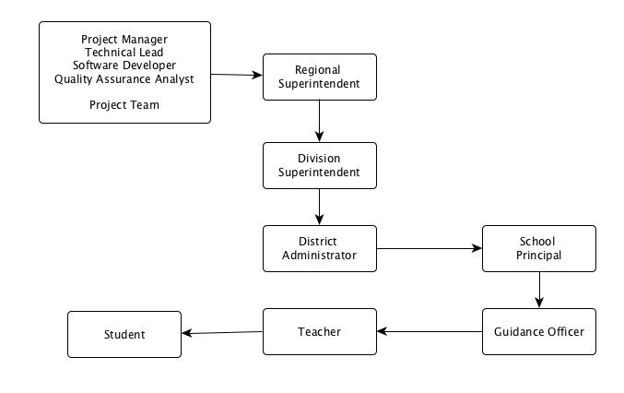

## **Internal Structure**

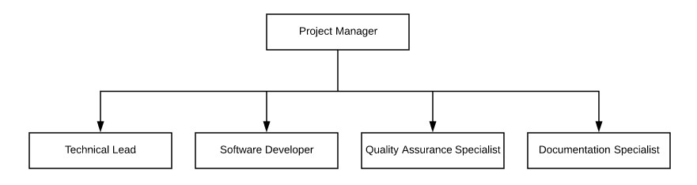

## **Roles and Responsibilities**

The following are the roles and responsibilities of the staff needed to implement the project. Responsibilities from the respective roles are gathered from PayScale.com, website providing salary, benefits, and compensation information.

|  |  |  |
| --- | --- | --- |
| **NAME** | **ROLES** | **RESPONSIBILITIES** |
| **Kyla Joyce Julian** | Project Manager | * Responsible for managing and leading the team * Monitor project progress and performance * Manage coordination with the team and client to ensure if the organization’s requirements are being fulfilled * Detailed project planning |
| **Rhea-Eve Ayungon** | Developer, Quality Assurance and Control Analyst, Integration Manager | * Analyze client requirements * Works with lead developer to ensure system compatibility and meet organization’s requirements * Responsible in ensuring the quality of the end product and its process * Responsible in system integration |
| **Kathrine Danielle Burton** | Database Analyst,  System Analyst, Documentation Lead | * Researching and examining current system and consulting users * Responsible in training the users and perform adequate support * Ensuring the security of databases and perform maintenance to guarantee the system’s performance * Responsible in documenting different phases of the project |
| **Joneil Thom**  **Llantos** | Lead Developer, Database Coordinator, Quality Assurance and Control Coordinator | * Programs software and writing of operating manuals * Works with system developer to ensure the system compatibility and meet organization’s requirements * Modifying and testing comprehensively the system to ensure the reliability of it * Undertake on system processes and analysis * Apply feasible solutions to possible problems |

# **MANAGERIAL PROCESS PLAN**

## **Start Up Plan**

### **4.1.1 Estimates**

|  |  |  |  |  |
| --- | --- | --- | --- | --- |
| **WBS** | **PHASE** | **TIME ESTIMATION (DAYS)** | **PARTICIPANTS** | **ESTIMATED COST** |
| 1 | Project Initiation | 10 | * Project Manager * Technical lead with PHP skills * Software Developer * Quality Assurance Analyst * Documentation Specialist | ₱49,268.60 |
| 2 | Planning | 14 | * Project Manager * Technical lead with PHP skills * Software Developer * Quality Assurance Analyst * Documentation Specialist | ₱81,361.94 |
| 3 | Execution | 72 | * Project Manager * Technical lead with PHP skills * Software Developer * Quality Assurance Analyst * Documentation Specialist | ₱410,390.36 |
| 4 | Project Closing | 4 | * Project Manager * Technical lead with PHP skills * Software Developer * Quality Assurance Analyst * Documentation Specialist | ₱14,788.38 |

### **4.1.2 Staffing**

This table contains and describes the skills that are needed by a person in order to qualify for a specific job. This also includes the number of employees that the client would need to meet the deadline that is stated in this table as well. Working days are from Monday to Friday, eight (8) hours a day.

|  |  |  |  |  |
| --- | --- | --- | --- | --- |
| **ROLE** | **REQUIRED SKILLS** | **NO. OF STAFF** | **START DATE** | **DURATION**  **(hours)** |
| **Project Manager** | * Good decision maker * Supreme communication (verbal and written) skills * Critical thinker * Control risk and minimize uncertainty | 1 | January 19, 2018 | 1,608 |
| **Technical Lead** | * Good communication skills * Logical and analytical approaches in problem solving * Strong problem skills * Has knowledge in CodeIgniter (Web) Framework * Committed to understand new technology associated with the software | 1 | January 19, 2018 | 1,920 |
| **Software Developer** | * Good communication skills * Deep and broad technical experience * Quick learning ability * Has knowledge in CodeIgniter (Web) Framework | 1 | January 19, 2018 | 1,656 |
| **Quality Assurance Analyst** | * High critical thinking skills * Good numerical skills and understanding of statistics * Detail oriented and points out the problem clearly | 1 | January 19, 2018 | 840 |
| **Documentation Specialist** | * Strong vocabulary powers * Detail oriented * Basic proficiency in MS Office Tools | 1 | January 19, 2018 | 480 |

### **4.1.3 Procurement Plan**

|  |  |  |  |  |  |  |
| --- | --- | --- | --- | --- | --- | --- |
| **ITEMS / SERVICES** | **JUSTIFICATION** | | **NEEDED BY** | **ACQUISITION METHOD** | **CONSTRAINTS** | **COST** |
| **HUMAN RESOURCES** | | | | | | |
| **Project Manager** | | A project manager is necessary as he will act as the director of the team and main communicator to the client. Also, the Project Manager is the one responsible in controlling risks and minimizing uncertainty. | Project Team | HR Hiring | Availability, Required Skills | ₱ 256,197.28 |
| **Technical Lead** | | A technical lead that has a deep understanding with Code Igniter is necessary as he will be the one capable of satisfying the requirements for the system. | Project Team | HR Hiring | Availability, Required Skills | ₱ 148,600.00 |
| **Software Developer** | | A software developer is necessary as the technical lead will need help from another person. The technical lead will need a reliable person that can analyze and study complex system requirements and troubleshoot and resolve issues in the software. | Project Team | HR Hiring | Availability, Required Skills | ₱ 88,855.20 |
| **ITEMS / SERVICES** | | **JUSTIFICATION** | **NEEDED BY** | **ACQUISITION METHOD** | **CONSTRAINTS** | **COST** |
| **HUMAN RESOURCES** | | | | | | |
| **Documentation Specialist** | | A documentation specialist is necessary as he will be the one to document everything, so it will be easier for the project manager to keep track of the progress of the team. | Project Team | HR Hiring | Availability, Required Skills | ₱ 16,256.00 |
| **Quality Assurance Analyst** | | A quality assurance analyst is necessary as he will be the one to monitor the software process and methods used to ensure quality. | Project Team | HR Hiring | Availability, Required Skills | ₱ 45,836.80 |
| **DOCUMENTATION** | | | | | | |
| **Office 365 Business** | | These set of documentation tool will be needed by the team in order to produce a written document regarding the project and in order for the team to collaborate | Project Team | License Purchasing | Internet Speed, Cost, Hardware Availability | ₱ 1,875.00 |
| **LucidChart: Online Diagram Software & Visual Solution** | | This software will provide elements that the team will use for their diagrams to be illustrated and explained in a more effective manner. | Documentation Specialist | Open Source Online | Cost, Hardware Availability | ₱ 1,790.00 |
| **ITEMS / SERVICES** | | **JUSTIFICATION** | **NEEDED BY** | **ACQUISITION METHOD** | **CONSTRAINTS** | **COST** |
| **DOCUMENTATION** | | | | | | |
| **GitHub Desktop** | | This software allows the team to upload files that will be needed for the project documentation and makes files more accessible. | Project Team | Open Source Download | Internet Speed, Hardware Availability | - |
| **Excel** | | A tool that was used by the project team in creating the WBS and Gantt Chart. | Project Manager | Open Source Download | Hardware Availability | - |
| **SOFTWARE DEVELOPMENT** | | | | | | |
| **XAMPP** | | This software acts as the HTTP Server and MariaDB Database. This is used to mimic a client-server environment via localhost. | Project Developer; System Designer | Open Source Download | Hardware Availability | - |
| **Sublime Text** | | This tool will help the project developer to easily navigate through the project folder (repository) and edit the source code of the system. | Project Developer; System Designer | License Purchasing | Cost, Hardware Availability | ₱ 4,180.00 |
| **ITEMS / SERVICES** | | **JUSTIFICATION** | **NEEDED BY** | **ITEMS / SERVICES** | **JUSTIFICATION** | **NEEDED BY** |
| **DOCUMENTATION** | | | | | | |
| **Google Chrome** | | This browser will be used as the medium to deploy the system as it is a web application | Project Team | Open Source Download | Internet Speed, Hardware Availability | - |
| **GitHub Desktop** | | This tool will help the team in connecting and performing various operations (commit, pull, push, merge, etc.) with the GitHub Repository. | Project Team | Open Source Download | Internet Speed, Hardware Availability | - |
| **HARDWARE** | | | | | | |
| **Acer Aspire E5-475G** | | This gadget serves as the platform to deploy and use the system. | Project Team |  | Cost | ₱ 33,000.00 |

### **4.1.4 Project Staffing Training**

This section of this project defines the necessary things needed to successfully deploy and implemented the project.

|  |  |  |
| --- | --- | --- |
| **TYPE** | **DESCRIPTION** | **TRAINER** |
| **Project Orientation** | The resources and details of the project are introduced and discussed | Project Manager |
| **Development Training** | Programming languages such as CodeIgniter are taught to the employees for the developing of the project system | Technical Lead |
| **Quality and Testing Training** | The tools and methods of testing the are introduced and discussed for the quality assurance of the project to know what are the needs to be improved | Quality Assurance Analyst |

## **Work Plan**

### **4.2.1 Work Breakdown Structure (WBS)**

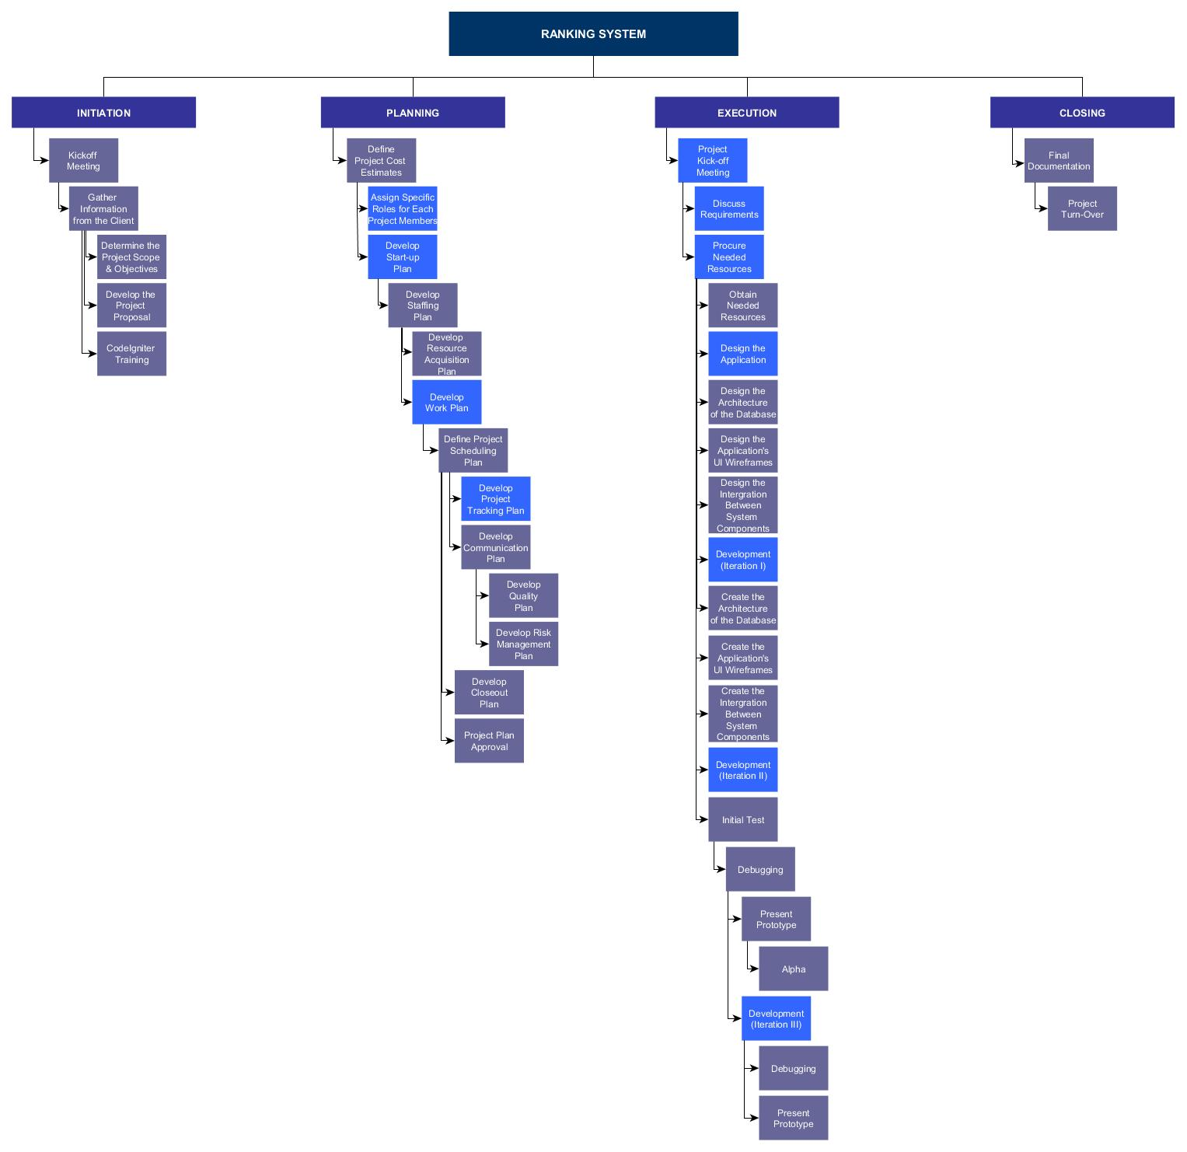

### **4.2.2 Resource Allocation**

|  |  |  |  |
| --- | --- | --- | --- |
| **ROLE** | **START** | **FINISH** | **OVERALL WORK DURATION**  **(hours)** |
| **Project Manager** | January 2018 | **May 2018** | **2,112** |
| **Technical Lead with PHP skills** | January 2018 | **May 2018** | **1,728** |
| **Software Developer** | January 2018 | **May 2018** | **1,512** |
| **Quality Assurance Manager** | January  2018 | **May 2018** | **192** |
| **Documentation Lead** | January 2018 | **May 2018** | **1,008** |

## **Project Tracking Plan**

### **4.3.1 Requirements Management**

|  |  |  |
| --- | --- | --- |
| **FOCUS** | **OBJECTIVE** | **REQUIREMENT** |
| **Scope** | The scope of the project must be identified both by the team and their client within a given time that they agree to meet. | * Project Team Meeting * Requirement Change |
| **Time** | The schedule must be strictly followed in order to avoid additional expenses and prevent delays in the project. | * Gantt Chart |
| **Cost** | The project cost should be able to play only within the range of the given budget. | * Budget Control Plan |
| **Quality** | The quality of the project must be constantly checked in order to achieve a quality project. | * Test Plan |

### **4.3.2 Schedule Control**

In this table, it illustrates the respective schedule of each tasks of the project team.

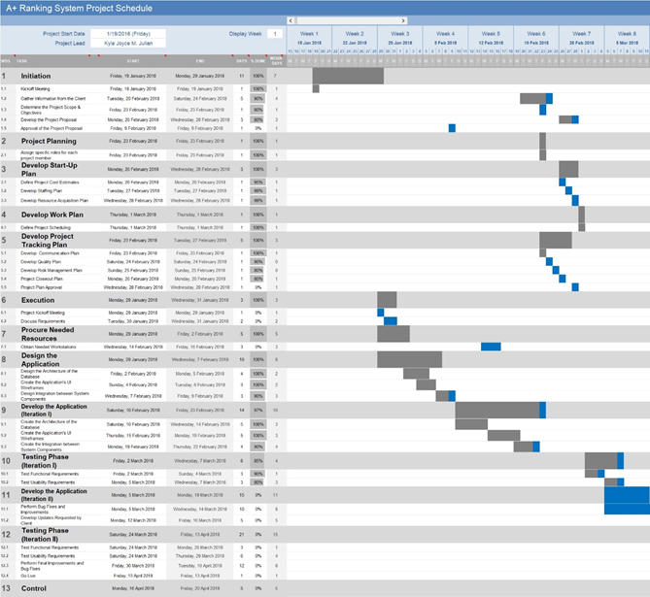

### **4.3.3 Budget Plan**

For the project to diminish the risk for over-budget or under-budget, the table below provides the list of resources, software and development tools.

|  |  |  |
| --- | --- | --- |
| **HUMAN RESOURCE** | | |
| **ROLE** | **SALARY * NO. OF DAYS** | **COST** |
| **Project Manager** | ₱ 3,823.84 * 67 | ₱ 256,197.28 |
| **Technical Lead with PHP skills** | ₱ 1,857.50 * 80 | ₱ 148, 600.00 |
| **Software Developer** | ₱ 1,410.40 * 63 | ₱ 88, 855.20 |
| **Quality Assurance Analyst** | ₱ 1,434.40 * 32 | ₱ 45,836.80 |
| **Documentation Specialist** | ₱ 812.8 * 20 | ₱ 16,256.00 |
| **Total Human Resource Cost** | | ₱ 555,745.00 |

|  |  |  |
| --- | --- | --- |
| **DOCUMENTATION COST** | | |
| **TOOL** | **UNIT PRICE * NO. OF MONTHS** | **TOTAL** |
| **Office 365 Business** | ₱ 468.75 * 4 | ₱ 1,875.00 |
| **LucidChart: Online Diagram Software & Visual Solution** | ₱ 447.50 * 4 | ₱ 1,790.00 |
| **Total Documentation Cost** | | ₱ 3,665.00 |

|  |  |  |
| --- | --- | --- |
| **SOFTWARE DEVELOPMENT COST** | | |
| **TOOL** | **UNIT PRICE * NO. OF MONTHS** | **TOTAL** |
| **Sublime Text** | ₱ 4,161.82 (lifetime) | ₱ 4,161.82 |
| **Total Software Cost** | | ₱ 4,161.82 |

|  |  |  |
| --- | --- | --- |
| **HARDWARE COST** | | |
| **TOOL** | **UNIT PRICE * QUANTITY** | **TOTAL** |
| **Acer Aspire E5-475G** | ₱ 33,000.00 * 4 | ₱ 132,000.00 |
| **Total Hardware Cost** | | ₱ 132,000.00 |

|  |  |
| --- | --- |
| **Total Cost Estimate** | ₱ 695,571.82 |

### **4.3.5 Quality Assurance Plan**

|  |  |  |
| --- | --- | --- |
| **MOODLE** | | |
| **TASK** | **QUALITY ASSURANCE** | **FORMAL RESPONSIBLE** |
| **Uniformity of major subjects**  **from Grade 2 to Grade 4** | All grade levels should have common major subjects which are Filipino, Mathematics, English, Science, and Araling Panlipunan | Quality Assurance Tester |
| **Availability of Quarterly**  **Assessment Exam** | Quarterly Assessment Exams should be posted and divided accordingly in moodle based on the grade level of students and the number of Quarters in a school year | Quality Assurance Tester |
| **Enrollment of Students** | Each student should be automatically enrolled in moodle according to their grade level | Quality Assurance Tester |
| **Validity of Results** | Each student should take each Quarterly Assessment Exam | Quality Assurance Tester |
| **Statistical Sampling** | Involves choosing parts of the population of interest for data gathering | Quality Assurance Tester |
| **MOODLE** | | |
| **TASK** | **QUALITY ASSURANCE** | **FORMAL RESPONSIBLE** |
| **Historical Data** | Involves using mathematical techniques to forecast future outcomes based on historical results and is used to monitor students’ performance | Quality Assurance Tester |
| **Access Control** | Each user of the system should have different permission to view data depending on their position. | Quality Assurance Tester |
| **OMR** | | |
| **Hardware Testing** | Assesses the performance of hardware components that will be used | Project Developer / Quality Assurance Analyst |
| **Bar Code Verification** | Ensure the 1:1 ratio of the Quarterly Exam Paper to the Students who are taking the Exam | Quality Assurance Analyst |
| **Scanning Duration** | Test the efficiency of the scanner by verifying that twenty exam papers can be scanned within a minute | Quality Assurance Analyst |
| **Checking Quarterly Exam** | Compare students’ answers to the correct answer and verify the result | Project Developer |

### 

### **4.3.5 Contingency Plan**

The project team proposed to have an additional 10% on the total budget cost to cover any unexpected circumstances during the construction process of the project.

|  |  |  |
| --- | --- | --- |
| **TOTAL BUDGET** | **ADDITIONAL PERCENTAGE** | **TOTAL CONTINGENCY** |
| ₱ 695,571.82 | 10% | ₱ 69,557.10 |

|  |  |  |
| --- | --- | --- |
| **CONTINGENCY BUDGET** | **TOTAL BUDGET** | **TOTAL** |
| ₱ 69,557.10 | ₱ 695,571.82 | ₱ 765,128.92 |

### **4.3.6 Communication Plan**

|  |  |  |  |  |
| --- | --- | --- | --- | --- |
| **TYPE OF COMMUNICATION** | **COMMUNICATION SCHEDULE** | **TYPICAL COMMUNICATION** | **INITIATOR** | **RECIPIENT** |
| **Team Meeting** | Every Tuesday and Friday | Meeting | Project Manager | Project Team |
| **Project Review** | Once a week | Meeting | Project Manager | Project Team |
| **Requirement Change** | When needed | Email/Meeting | Adviser | Project Team |
| **Project Consultation** | When needed | Meeting | Adviser | Project Team |
| **Documentation Review/Update** | When needed | Email/Meeting | Project Manager | Project Team |

### 

### **4.3.7 Project Metrics**

|  |  |
| --- | --- |
| **LEGEND** | |
| **R** | Responsible |
| **A** | Accountable |
| **C** | Consulted |
| **I** | Informed |

|  |  |  |  |  |
| --- | --- | --- | --- | --- |
| **INITIATION** | **PROJECT MANAGE RPROJECT MANAGER** | **PROJECT DEVELOP PROJECT DEVELOPER** | **QUALITY ASSURANCEQUALITY ASSURANCE** | **SYSTEM ANALYST SYSTEM ANALYST** |
| **Project Team Creation** | A | R | I | I |
| **Determine Project** | A | I | R |  |
| **Project Team Creation** | A | R | I | I |
| **Determine Project** | A | I | R | C |
| **Identifying Requirements** | A | I | R | C |
| **Develop Project Proposal** | A | I | R | C |
| **PLANNING** |  |  |  |  |
| **Information Gathering** | A | R | I | I |
| **Delegation of Task** | A/R | I | I | I |
| **Define Scope** | A | R | I | I |
| **Develop Project Plan** | A | R | I | C |
| **Team and Client Meeting** | R | I | A | C |
| **EXECUTION** |  |  |  |  |
| **System Design** | A | R | I | C |
| **Client Meeting** | A | I | R | C |
| **System Development** | I | R | A | C |

|  |  |  |  |  |
| --- | --- | --- | --- | --- |
| **MONITORING AND CONTROLLING** |  |  |  |  |
| **Create Quality Assurance Plan** | R | A | A | C |
| **Perform Quality Testing** | R | A | A | C |
| **Account Restrictions** | I | R | A | A |
| **CLOSING** |  |  |  |  |
| **Finalizing of Documents** | A | I | R | R |
| **Turnover System to Client** | A | I | R | C |

## **Risk Management Plan**

This section identifies, prioritize, and analyzes all the risk factors that can affect concerning the project. It also specifies plans for assessing initial risk factors and for the ongoing identification, assessment, and mitigation of risk factors throughout the life cycle of the project.

|  |  |  |  |  |  |
| --- | --- | --- | --- | --- | --- |
| **RISK** | **DESCRIPTION** | **TRIGGER** | **MITIGATION** | **RISK OWNER** | **RISK PROBABILITY** |
| Over-budget | Spent more than the allotted given budget. | Overspending | Make a request for additional funding, diminishing the project’s scope, and reduce cost by having an alternative product. | Project Manager | Medium |
| Client Availability | The availability of the client for meetings didn’t match with the team. | Schedule conflict | Persuade the client to be committed in this project and have a second person responsible if the schedules still didn’t match. | DepEd | Low |

|  |  |  |  |  |  |
| --- | --- | --- | --- | --- | --- |
| **RISK** | **DESCRIPTION** | **TRIGGER** | **MITIGATION** | **RISK OWNER** | **RISK PROBABILITY** |
| Behind the Schedule | Deliverables were not submitted on time. | Delayed outputs | Do some overtime or extend the deadline. Another one is to change the scope, and include more resources. | Project Team | Low |
| New Administration | The administration that signed the contract was replaced by a new one and the new administration have another project in mind. | There’s a new administration seated. | Decrease the planned scope. | DepEd | Low |
| Absence or tardiness of the employees | The employees were not always present | The project were not delivered on time | Set some rules within the project team or assign multiple task for each employee | Project Manager | Medium |

## **Project Closeout Plan**

The following are the processes needed to be accomplished for the project closeout plan:

* All requirements such as documents and system must accomplish and fully functional
* All contingencies and deliverables are met its goal
* All actual costs of the project must be met and must be maintained based on the proposed budget.
* All risks or potential liabilities met the mitigation of the problem
* The team has successfully scheduled a meeting to discuss various features regarding the system.
* The system and the documentation has been handled by Leonor Briones of Department of Education.

# **TECHNICAL PROCESS PLAN**

## **Process Model**

The figure below visualizes the Scrum methodology to be used during the Executing Phase, where most of the Software Development tasks are located.

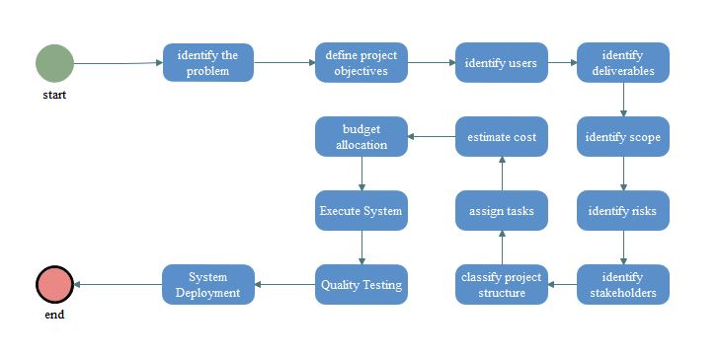

## **Methods, Tools and Techniques**

|  |  |
| --- | --- |
| **SYSTEM DEVELOPMENT** | |
| **TOOL** | **TOOL PURPOSE** |
| **Sublime Text Editor** | developing, debugging and testing program codes |
| **phpMyAdmin** | handle administration of system's database (MySQL) with the use of a web browser |
| **GitHub** | repository for version control system |
| **Google Chrome** | served as a platform to display system's output |
| **XAMPP Application** | platform used to process and send request from the user specifically in system implementation within the environment |
| **CodeIgniter PHP Framework** | for building and deploying system |

## **Product Acceptance**

To ensure that the customers will accept the product of the project. First will be tested by the developers (alpha test) after bugs are determined and fixed for three iterations. The product of the project will be opened for beta testing. Here are other ways to ensure product acceptance:

* There will be demonstrations for the users to understand and learn the mechanics of the product.
* User manuals will be given to users, which will serve as a guide on how to use the product.
* The deliverables and product were properly reviewed, tested or audited by the team.

# **SUPPORTING PROCESS PLAN**

## **Configuration Management**

The Configuration Management Plan covers all the progress and changes in each documentation made by each member of the group and system made by the software development group. The Project Manager of the group is responsible for checking baseline plans and execution of the Configuration Management Plan made by all members of the group

## **Documentation**

The project team will provide a complete list of the documentation details of all the things that they find important, schedules, tasks, events, progress, status, etc.

|  |  |  |  |  |  |
| --- | --- | --- | --- | --- | --- |
| **DOCUMENT** | **TEMPLATE** | **CREATED BY** | **REVIEWED BY** | **TARGET DATE** | **DISTRIBUTION** |
| Project Proposal | Microsoft Word | Project Team | Project Manager | January 24, 2018 | Project Team |
| Test Plan | Microsoft Word | Project Team | Project Team | February 02, 2018 | Project Team |
| Risk Management Plan | Microsoft Word | Project Team | Project Manager | February 5, 2018 | Project Team |
| Cost Management Plan | Microsoft Word | Project Team | Project Team | January 25, 2018 | Project Team |
| Budget Allocation | Microsoft Word | Project Team | Project Manager | January 30, 2018 | Project Team |
| Quality Assurance Plan | Microsoft Word | Project Team | Project Manager | February 2, 2018 | Project Team |
| Work Breakdown Structure | Microsoft Word | Project Team | Project Team | February 1, 2018 | Project Manager |

## **Process Improvement**

The System that is proposed in this paper is ready to use and its functionalities are working. However, just like any other system, there are still room for improvement such as:

* Data can be viewed in other devices such as mobile phones and tablets.
* The users may use historical data in order to predict student performance

# **REFERENCES**

*About DepEd*. (n.d.). From Department of Education: http://www.deped.gov.ph/mandate

*About Moodle*. (2018, March 1). From Moodle: https://docs.moodle.org/34/en/About_Moodle

Automatic Document Feeder (ADF). (2018). *Technopedia*.

Balderas, D. D. (2017). Division Memorandum No. 396. *Conduct of Quarter Tests*.

Gravic. (2018). What is OMR (Optical Mark Recognition)? *Remark*.

Inc., P. (2018). Quality Assurance Manager Salary. *PayScale*.

Maria Celia Junio-Fernandez, E. (2017). Division Policy Guidelines on the Administration of Quarterly Examination. *Schools Division Office*, 1.

PHP. (2018). *What is PHP?*, http://php.net/manual/en/intro-whatis.php.

PricePrice. (2018, April 13). *ph.priceprice.com*. From Priceprice.com: http://ph.priceprice.com/Acer-Aspire-E5-475G-24799/

Roseke, B. (2018). What is Project Deliverable? *Project Engineer*.

Siegelaub, J. M. (2007). Six (yes six!) Constraints. *An Enhanced Model for Project Control*.

Work Breakdown Structure. (2018). *Work Breakdown Structure (WBS)*, http://www.workbreakdownstructure.com/.

Yakubovitch, M. (2015). Project Management. *How to Define Project Deliverables*.